DURHAM CATHOLIC DISTRICT SCHOOL BOARD
Catholic Education: Learning & Living in Faith

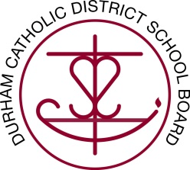

Lunch Hour Supervisors Required

Monsignor John Pereyma C.S.S. is looking for Lunch Hour Supervisors to assist school staff in maintaining a safe learning environment for our students.

As a Lunch Hour Supervisor, you will be responsible for assisting staff with the supervision of students located on the school premises primarily during the daily lunch period.

Interested candidates are invited to apply directly to school Principal at Monsignor John Pereyma, 316 Conant Street, Oshawa, Ontario and may access information regarding any school on our Board web site at www.dcdsb.ca.

Please note: Recommended candidates must provide a recent (within the past six months) Criminal Reference Check with Vulnerable Sector from an authorized police agency, e.g. Durham Regional Police Service.

